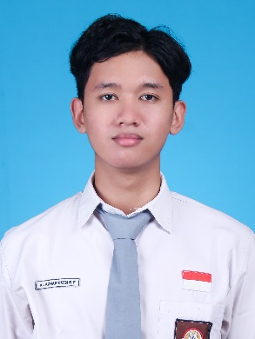NAMA : AL AZHAR RIZQI RIFA’I FIRDAUS

NIM : 2241720263

KELAS : 1 I

PRODI : D-IV TEKNIK INFORMATIKA

MATA KULIAH : B. INGGRIS

DOSEN : IBU ATIQAH NURUL ASRI, SPD, MPD

Information About My Self

Helo, let me introduce my self. My name is AL AZHAR RIZQI RIFA’I FIRDAUS. Other people used to call me Azhar. I was born in Surabaya, August 24 2003 2:35 PM. I don’t have a brother or sister because I’m an only child.

My home address is on Candi Agung IV Street number 10. I graduate from Vocational High School 4 Malang, software engineering major.Very happy to feel the school at Vocational High School 4 Malang because I have a lot of solid friends.

At Vocational High School 4 Malang, I learned a lot of programming. I have learn Django, a framework from python language, to develop backend website and flutter, a framework from dart language, to develop android apps. My motivation to enter the informatic engineering study program is to gain higher knowledge of programming. Because I believe money will follow the value.

I also have some hobbies. Among others are jogging, swimming, playing badminton, and reading book. Usually I jogging on Saturday morning, or Sunday morning. Because I know sports is very important for health. I have been finished reading 2 book. Among them is Atomic Habits and The Psychology of Money. There are many lesson to be learned from reading these two books. For now I’m also reading a book whose title is The Subtitle Art of Not Giving a f written by Mark Manson.

I also have a side hustle as a Gojek driver and Shopee Food driver. Very nice to feel this work, because I can learn to be independent to raise money. But some moments I find it difficult to manage the time where am I at school too, but thanks I can handle it.

That’s all for information about me, I apologize if there are words that are not wearing. Thank you.